**Final Exams Report.**

**Rebecca Osei Akoto.**

Name of Business: De_hairmatezgh.

Owner’s name: Ramatu

Email: N/A

Location: Bekwai.

Business Model.

De_hairmatez is a hair studio that provides quality and affordable wig extensions, wiglets and other traditional salon services to its customers. We are committed to making our clients look beautiful at a minimal cost. The revenue model of this hair studio is a transactional revenue model, which means that customers make one-time payments for the product. The market space of operation is for all groups of females, and it is an online/ physical shop. The customer can buy the wig extension online or walk to the shop to purchase. We have lots of competitors. Most of our competitors operate on social media, and some of them include wigclub, hair duties, santes hair and hairsenta. Our main comparative advantage is providing home service and bridal styles for our customers. It is very affordable and has a good customer relationship strategy. The primary marketing strategy of de_hairmatezis social media platforms. We will use Facebook, Instagram and WhatsApp to promote our brands and hire influencers to represent our brands. The organizational structure comprises the Chief Executive Officer (CEO), who serves as the manager and financial manager. The management team is made up of Ramatu and her influencers.

2. Architecture and design

Agile method was used in implementing this website. This is because the agile method allows for iterations.

|  |  |  |
| --- | --- | --- |
| **Business motive** | **System Functionality** | **Information Requirement** |
| Show all products | Ecommerce Digital catalog | Text and graphics catalog |
| Perform transactions | Payment system (paystack) | Mobile money payment option |
| Combine customer details | Database for customers (mysql) | Customer name, address, number, email, ID |

**System Development Life Cycle (Design & Architecture)**

The 3-tier architecture

**A Signed Contract**

**Signed by Rama studios**

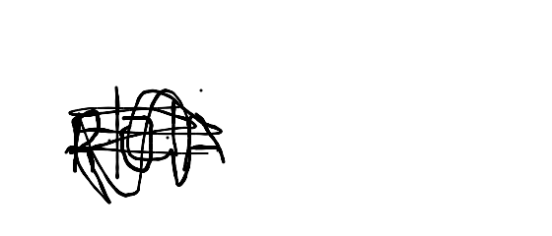

**Framework.**

The frameworks ude were HTML, CSS, PHP,BOOTSRAP AND JAVASCRIPT.

Flow diagram.

Snippets from code

URL or server IP address

https://hairstudios.herokuapp.com/

Link to video demo

https://aucampus-my.sharepoint.com/:f:/g/personal/rebecca_akoto_ashesi_edu_gh/EqW88jI4X1BEoMOt5sYdb90BslxTrBRZR6ThDKMzLZ8BQw?e=2YfFNP

Source Code (GITHUB Link)

https://github.com/Rebeccaakoto/hairstudio.git